1.Class and Sequence diagram of Order Tracking System

1.1 class diagram

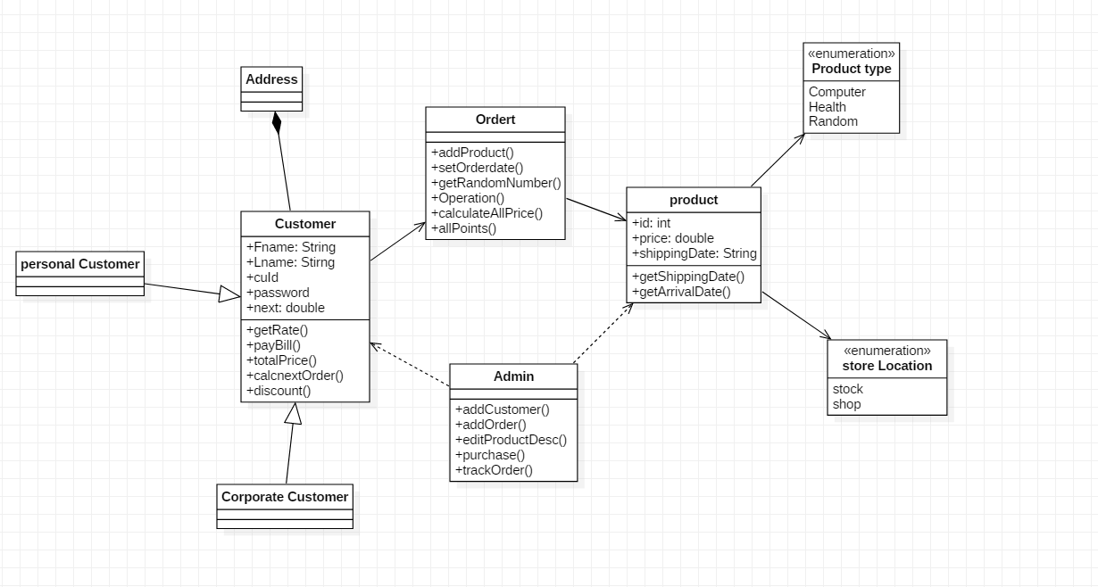

1.2 Billing for Corporate customer

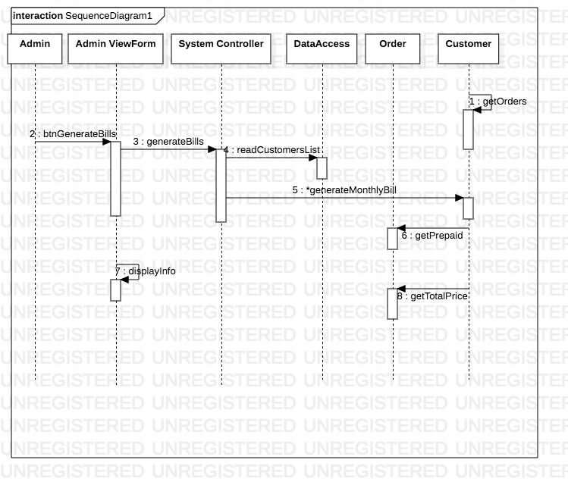

1.3 addProduct

